#### **Proposal (Final Project)**

* Names of team members: Nithya and Sam
* Name of your team's GitHub repository
  + Happiness and Inequality
    - <https://github.com/sam-maniscalco/Happiness-and-Inequality>
* A primary dataset you intend to analyze,
  + Human Development Index
    - <http://hdr.undp.org/en/content/human-development-index-hdi>
  + World Happiness Report
    - <https://www.kaggle.com/unsdsn/world-happiness#2019.csv>
* Project idea and Learning Objective

We aim to study how inequality levels and happiness levels have evolved in different countries over the last few years and see whether there are any similarities in patterns that emerge in changes in inequality and happiness levels over time. Our initial hypothesis is that happiness may depend on relative rather than absolute levels of deprivation and we aim to use data visualization and descriptive tools from Python libraries (such as ggplot, matplotlib, bokeh etc.) to be able to see time trends. Preliminary literature review on these topics has indicated that this is an important and developing topic within international development and we aim to develop greater familiarity with these important datasets as well as with Python’s data analysis and visualization techniques and libraries

Some initial plots, figures, or tables on these topics that have motivated this study:

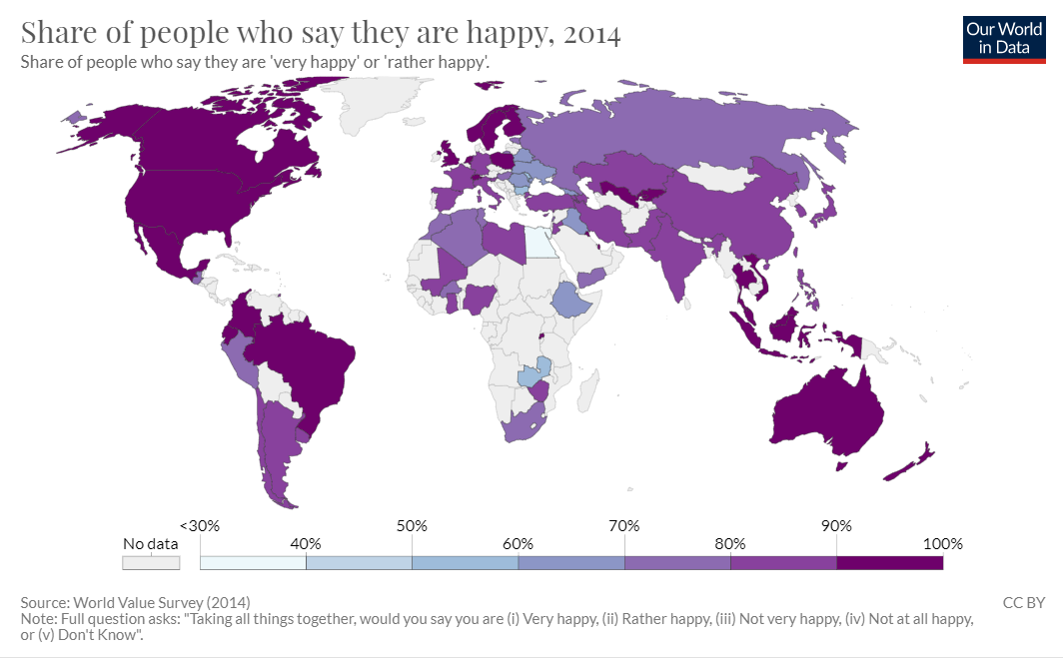

Source: [World Value Survey](https://ourworldindata.org/happiness-and-life-satisfaction)

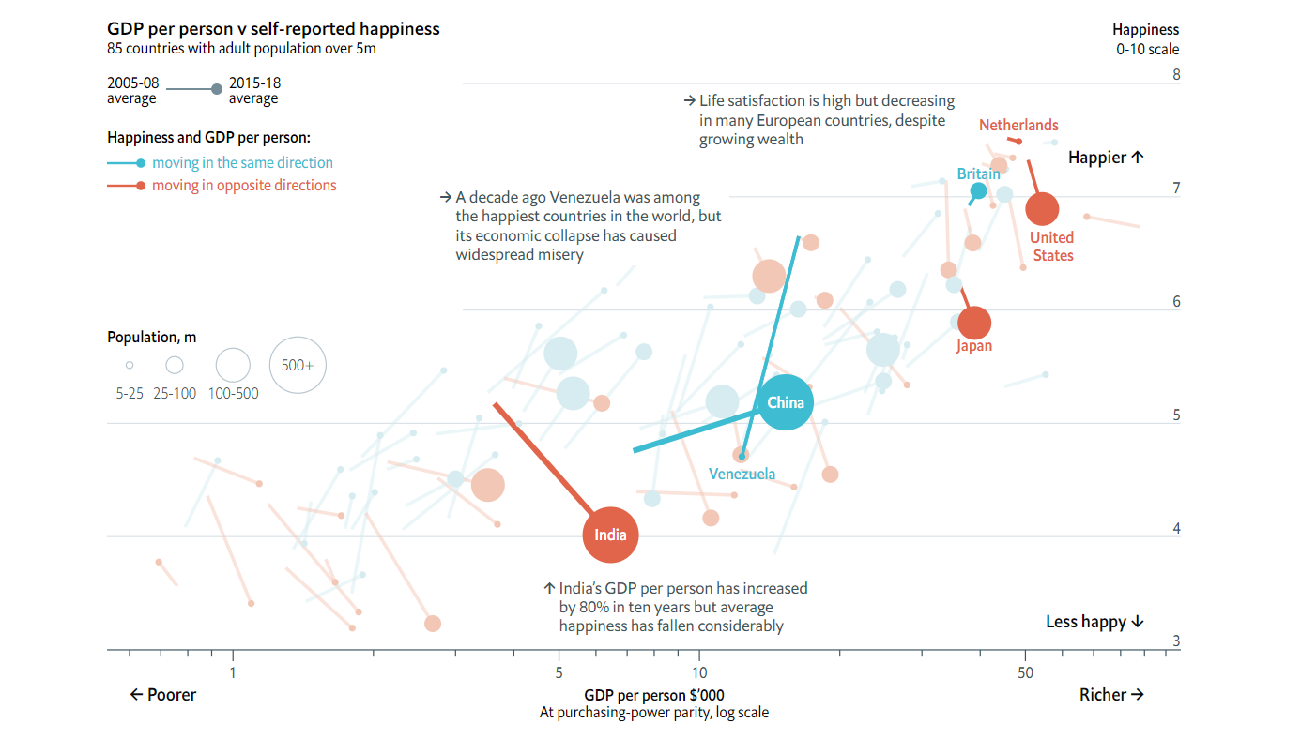

*Source:* [*The Economist*](https://www.economist.com/graphic-detail/2019/03/21/economic-growth-does-not-guarantee-rising-happiness)

* Some of the variables (column names) you intend to explore and what kind of insights you expect to glean,
  + We intend to explore some of the variables in Table 3 of the HDI report regarding inequality, such as the Gini Coefficient, coefficient of human inequality, and inequality in life expectancy, income, and education. Visualizing these variables over time will allow us to identify trends in the progression of inequality across the globe over the past, say 10 years. We will then compare these trends to the rate of change in global happiness, as measured by the World Happiness Report utilizing variables like each country’s overall score, as well as its component variables, like the degree of social protection within a country. The comparison of trends between the two measures, inequality and happiness, might provide insights into the degree to which happiness is influenced by inequality—are inequality and happiness proportionally related? Do changes in inequality levels correlate with changes in happiness? To what extent do the different component measures of inequality (life expectancy, education, income, gender) relate to the levels of reported happiness in a country? As these are purely descriptive analyses, we do not intend to try and ascertain causation, but to observe trends, and hopefully observe some relationship that we can try to parse out.
  + We also intend on exploring some of the more aggregate indices in the data, such as the Gender Inequality Index, Human Development Index, and Multidimensional Poverty Index. In visualizing these indices and their progression over time, we will be able to further analyze the relationship between trends in human development, social protections, among other factors and the changes in happiness we visualize using the World Happiness Report.
* supplemental datasets, if any, to complement your primary dataset - this means links, columns that you'll join on, etc.,
  + World Happiness Report
    - <https://www.kaggle.com/unsdsn/world-happiness#2019.csv>
  + Maybe World Development Indicators from the World Bank
    - <https://www.kaggle.com/worldbank/world-development-indicators/data>
* What you plan to cover in the final report and how you plan to organize it.

Topics to be covered: as mentioned in the project objective and variables question

Rough Outline for final report:

* + Introduction and literature review
  + Project idea and objective
  + Data sources
  + Data Visualization (graphs, tables, maps etc.)
  + (This would be the most detailed section as learning how to efficiently work with these tools is what we hope to learn from this project)
  + Interpretations
  + Conclusion and next steps